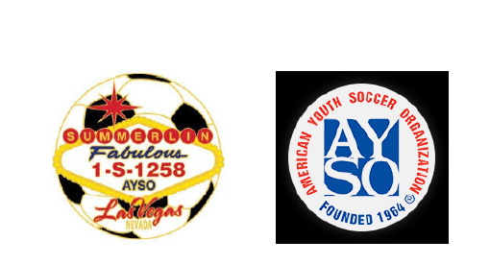

AYSO Region 1258 Board Meeting Minutes

Date: Monday July 14th, 2025

Time: 7:00PM

Location: Virtual via Zoom

Attendees will be checked:

|  |  |  |
| --- | --- | --- |
| Kim Wilkinson | Denise Kubajak | Jill Contreras |
| Mindy Veytia | Tim Downing | Andrew Contreras |
| Mike Bauder | Heather Nail | Kennedy Sanchez |
| Mike Schramm | Max Corrick | Andrew Musgrove |

**Topic 1: Motion to approve minutes for 07/07:**

1. Andrew Contreras
2. Denise Kubajak

**Topic 2: Denise: Registration Numbers-**

|  |  |  |  |
| --- | --- | --- | --- |
| **Division** | **Girls** | **Boys** | **Coed** |
| **6U** | **17** | **17** | **~~~~~~~~~~~~~~~** |
| **8U** | **51** | **58** | **~~~~~~~~~~~~~~~** |
| **10U** | **48** | **47** | **~~~~~~~~~~~~~~~** |
| **12U** | **37** | **64** | **~~~~~~~~~~~~~~~** |
| **14U** | **27** | **48** | **~~~~~~~~~~~~~~~** |
| **18U** | **~~~~~~~~~~~~~~~~** | **~~~~~~~~~~~~~~~~** | **44** |
|  |  |  | **TOTAL: 458** |

**Topic 3**: Coach list still being generated. Current list has been sent out to the division coordinators.

**Topic 4:** Team rosters will only be given to coaches who have completed their background checks.

**Topic 5:** National Leagues play next week in Irvine, CA. GOOD LUCK!!! 😉

**Topic 6: Next board meeting Monday July 28th, 2025 via Zoom**